Please start your paper with choice of topic categories. Do not indicate any of author’s personal information.

**Preparation of Digest in One-Column Format**

**for the ICPE 2019-ECCE Asia**

Abstract—These instructions provide basic guidelines for preparing Digest for the ICPE 2019-ECCE Asia

# **Introduction**

Digests should not exceed four pages. Each page should be a single column on forth American A size (210mm x 297mm). The minimum font size is 10 points. Margins for the page is 3cm top, 2.5cm bottom, left and right.

The digest is an extended summary of your work. Start by describing the problem your work addresses. Describe your work and how it contributes to the solution of the problem. Include, if relevant, as much evidence of completed experimental as possible.

## **Here is a subsection**

Here is a subsection. Here is a subsection. Here is a subsection. Here is a subsection. Here is a subsection. Here is a subsection. Here is a subsection. Here is a subsection.

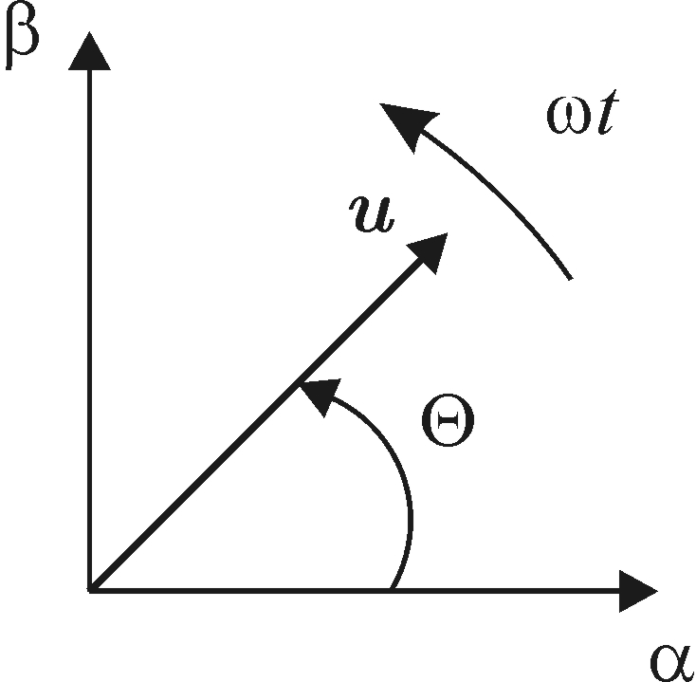

Fig. 1:  Figure in a two columns paper

# **Next Section Text**

Next section text. Next section text. Next section text. Next section text. Next section text. Next section text. Next section text. Next section text. Next section text. Next section text. Next section text. Next section text. Next section text. Next section text. Next section text. Next section text. Next section text. Next section text. Next section text. Next section text. Next section text.

1. ***Your subsection text***

Your subsection text. Your subsection text. Your subsection text. Your subsection text. Your subsection text. Your subsection text. Your subsection text. Your subsection text. Your subsection text. Your subsection text. Your subsection text. Your subsection text. Your subsection text. Your subsection text. Your subsection text. Your subsection text. Your subsection text. Your subsection text. Your subsection text. Your subsection text. Your subsection text. Your subsection text.

***B. Subsubsection Heading Here***



(2)

(1)

Subsection is here. Subsection is here. Subsection is here. Subsection is here. Subsection is here. Subsection is here. Subsection is here. Subsection is here. Subsection is here. Subsection is here. Subsection is here. Subsection is here. Subsection is here. Subsection is here. Subsection is here. Subsection is here. Subsection is here. Subsection is here. Subsection is here. Subsection is here. Subsection is here. Subsection is here. Subsection is here. Subsection is here. Subsection is here. Subsection is here. Subsection is here. Subsection is here. Subsection is here. Subsection is here. Subsection is here. Subsection is here. Subsection is here. Subsection is here. Subsection is here. Subsection is here. Subsection is here. Subsection is here. Subsection is here

# **Conclusion**

Here goes conclusion. Here goes conclusion. Here goes conclusion. Here goes conclusion. Here goes conclusion. Here goes conclusion. Here goes conclusion. Here goes conclusion. Here goes conclusion. Here goes conclusion. Here goes conclusion. Here goes conclusion. Here goes conclusion. Here goes conclusion. Here goes conclusion. Here goes conclusion. Here goes conclusion. Here goes conclusion. Here goes conclusion. Here goes conclusion. Here goes conclusion. Here goes conclusion. Here goes conclusion. Here goes conclusion. Here goes conclusion. Here goes conclusion. Here goes conclusion. Here goes conclusion. Here goes conclusion. Here goes conclusion. Here goes conclusion. Here goes conclusion. Here goes conclusion. Here goes conclusion. Here goes conclusion. Here goes conclusion. Here goes conclusion. Here goes conclusion. Here goes conclusion. Here goes conclusion. Here goes conclusion. Here goes conclusion. Here goes conclusion. Here goes conclusion. Here goes conclusion. Here goes conclusion. Here goes conclusion.

# **References**

[1] And here is reference. And here is reference. And here is reference. And here is reference. And here is reference. [2] And here is reference. And here is reference. And here is reference. And here is reference. And here is reference. [3] And here is reference. And here is reference. And here is reference. And here is reference. And here is reference. [4] And here is reference. And here is reference. And here is reference. And here is reference. And here is reference.

[5] And here is reference. And here is reference. And here is reference. And here is reference. And here is reference. [6] And here is reference. And here is reference. And here is reference. And here is reference. And here is reference. [7] And here is reference. And here is reference. And here is reference. And here is reference. And here is reference. [8] And here is reference. And here is reference. And here is reference. And here is reference. And here is reference. [9] And here is reference. And here is reference. And here is reference. And here is reference. And here is reference.

**Guideline for Digest Submission**

* Papers presented at ICPE 2019-ECCE Asia must be original material and must not have been presented or published previously. All digests must comply with the export control laws of the country or countries in which the author(s) reside. A statement of compliance will be required as part of the submission process. All authors should obtain company and governmental clearance prior to submission of Digests. Digests marked or labeled as “Confidential”, “Proprietary” or with similar wording will not be accepted.
* The digest should give a clear and concise statement of the purpose and contribution of the work, specific results and the methods used. Include key equations, figures and tables. ICPE 2019-ECCE Asia reviewers value highly evidence of completed experimental work such as oscillograms and photos of equipment under test.
* Digest should be written in 4 pages or less, single column, and single-space on A4 sized format including figures and tables. Line space can be adjusted upto 1.5. Number all Digest pages. Digests should be submitted as the Adobe Acrobat PDF file (*.pdf).
* Please do not write authors' names and affiliations on the digest for peer review